5.Create A Cloud Software Application For Library Book Reservation System Using Any Cloud Service Provider To Demonstrate Software As A Service (Saas) .
AIM :
To create a cloud-based software application for library book reservation system using a cloud service provider and demonstrate the Software as a Service (SaaS) model.
PROCEDURE
- A cloud service provider such as Zoho Creator is selected to develop the application.
- A new cloud application named Library Book Reservation System is created.
- Forms such as Book Details, Member Details, and Reservation Request are designed in the cloud platform.
- The application is hosted on the cloud and made accessible through a web browser.
- Book catalog, member profiles, and reservation records are stored securely in the cloud database.
- Reports are generated to view available books, reservation status, and overdue lists.
- The application is tested to ensure proper functionality and cloud accessibility.

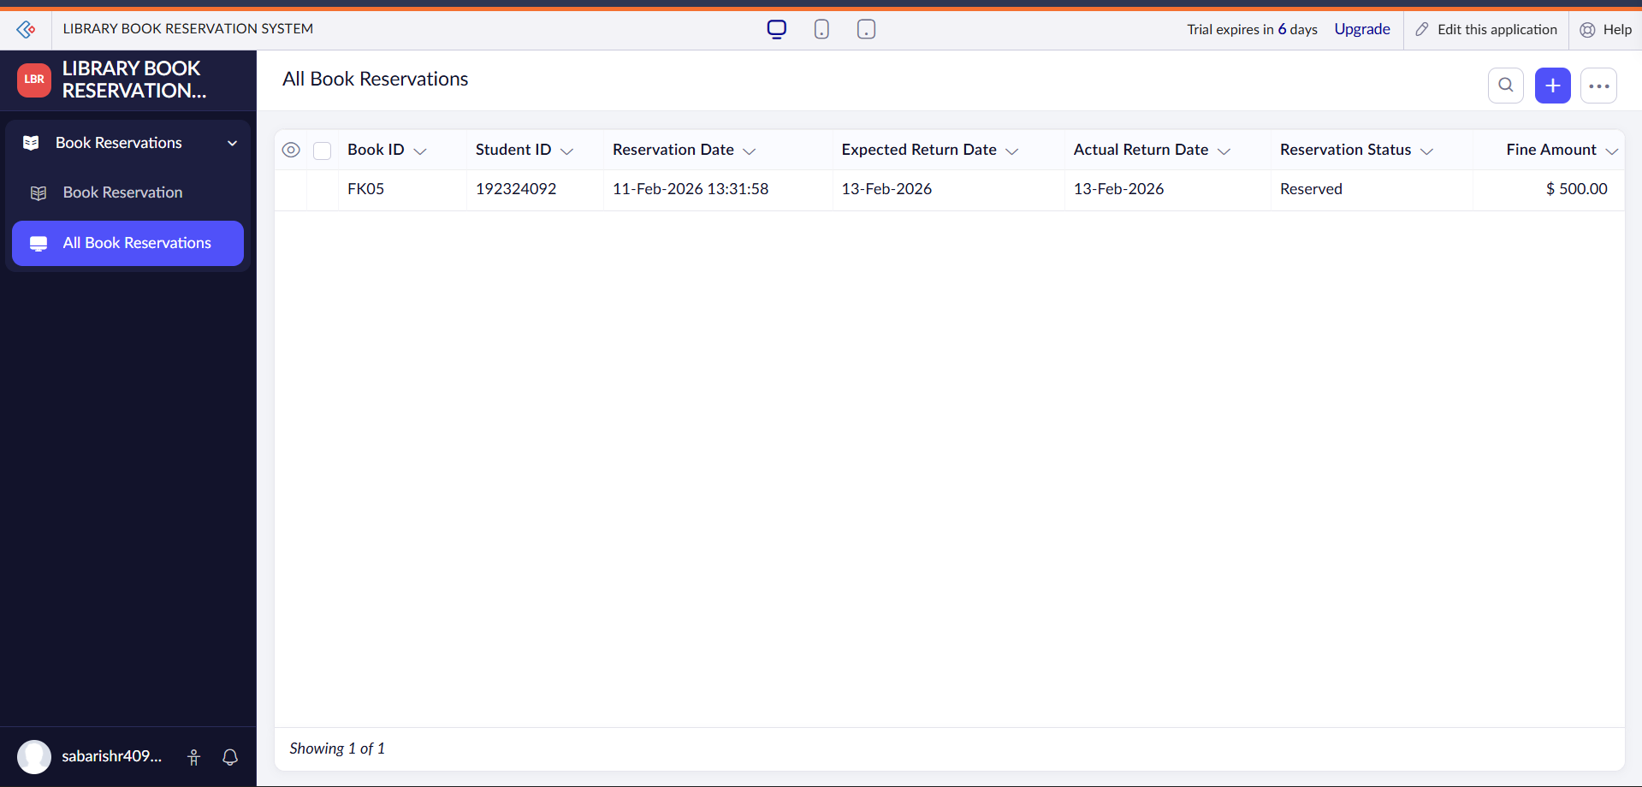
RESULT :

